**Task 1.A: Implement a Simple Kernel Module**

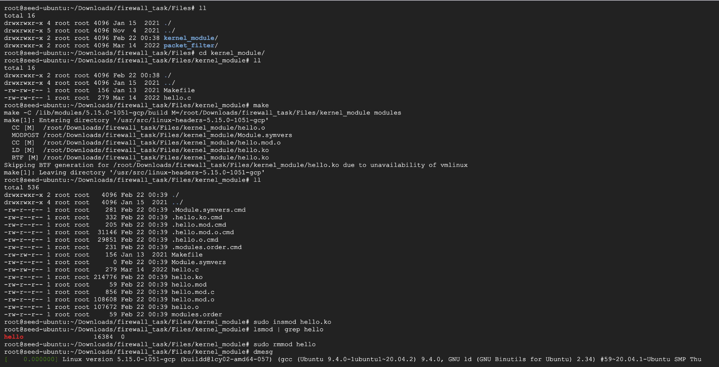

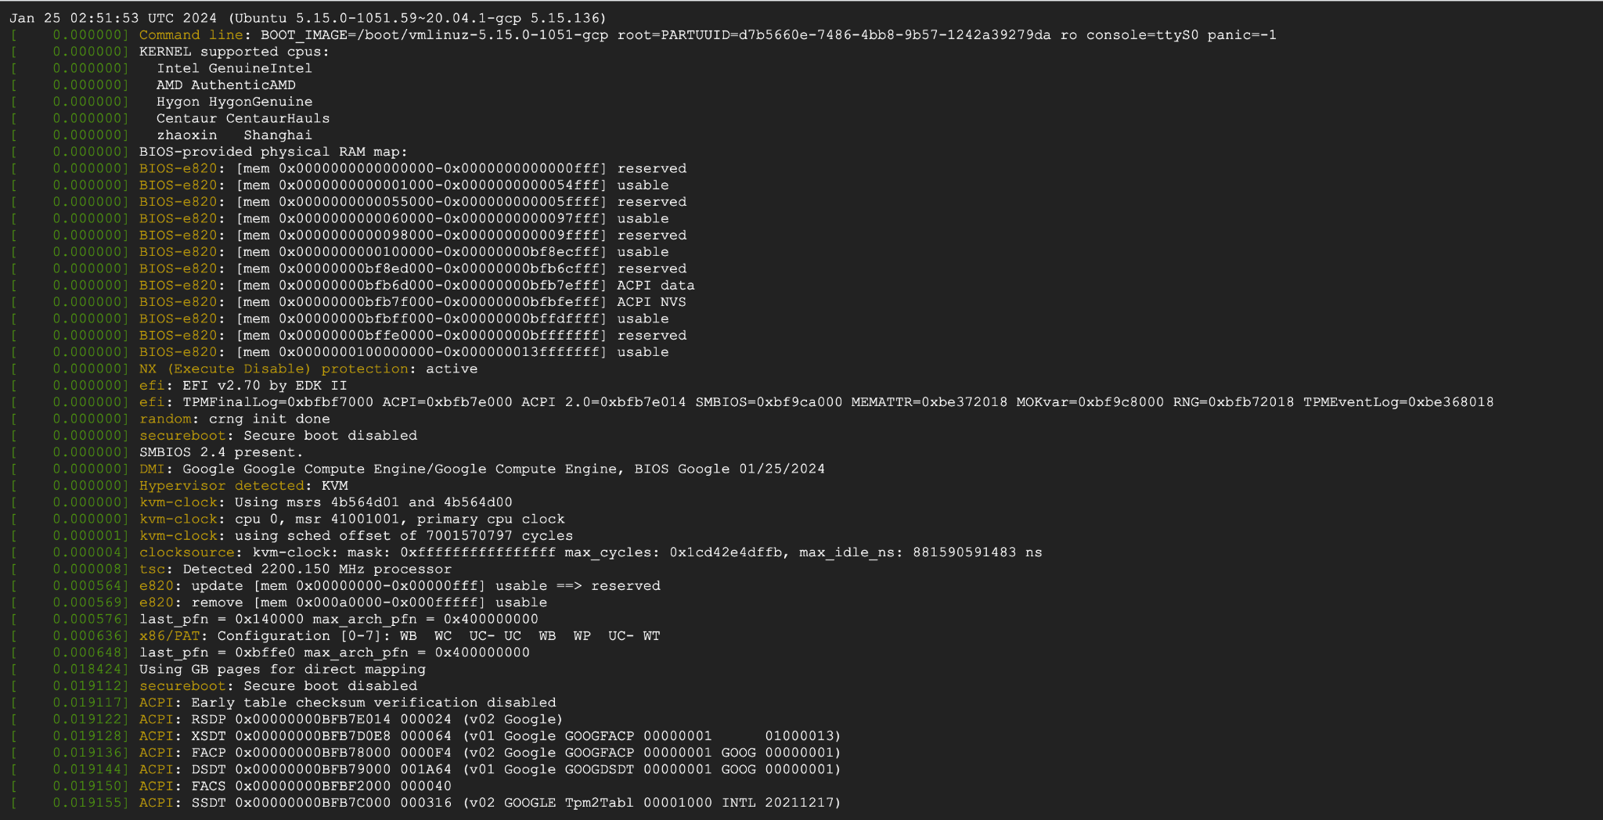

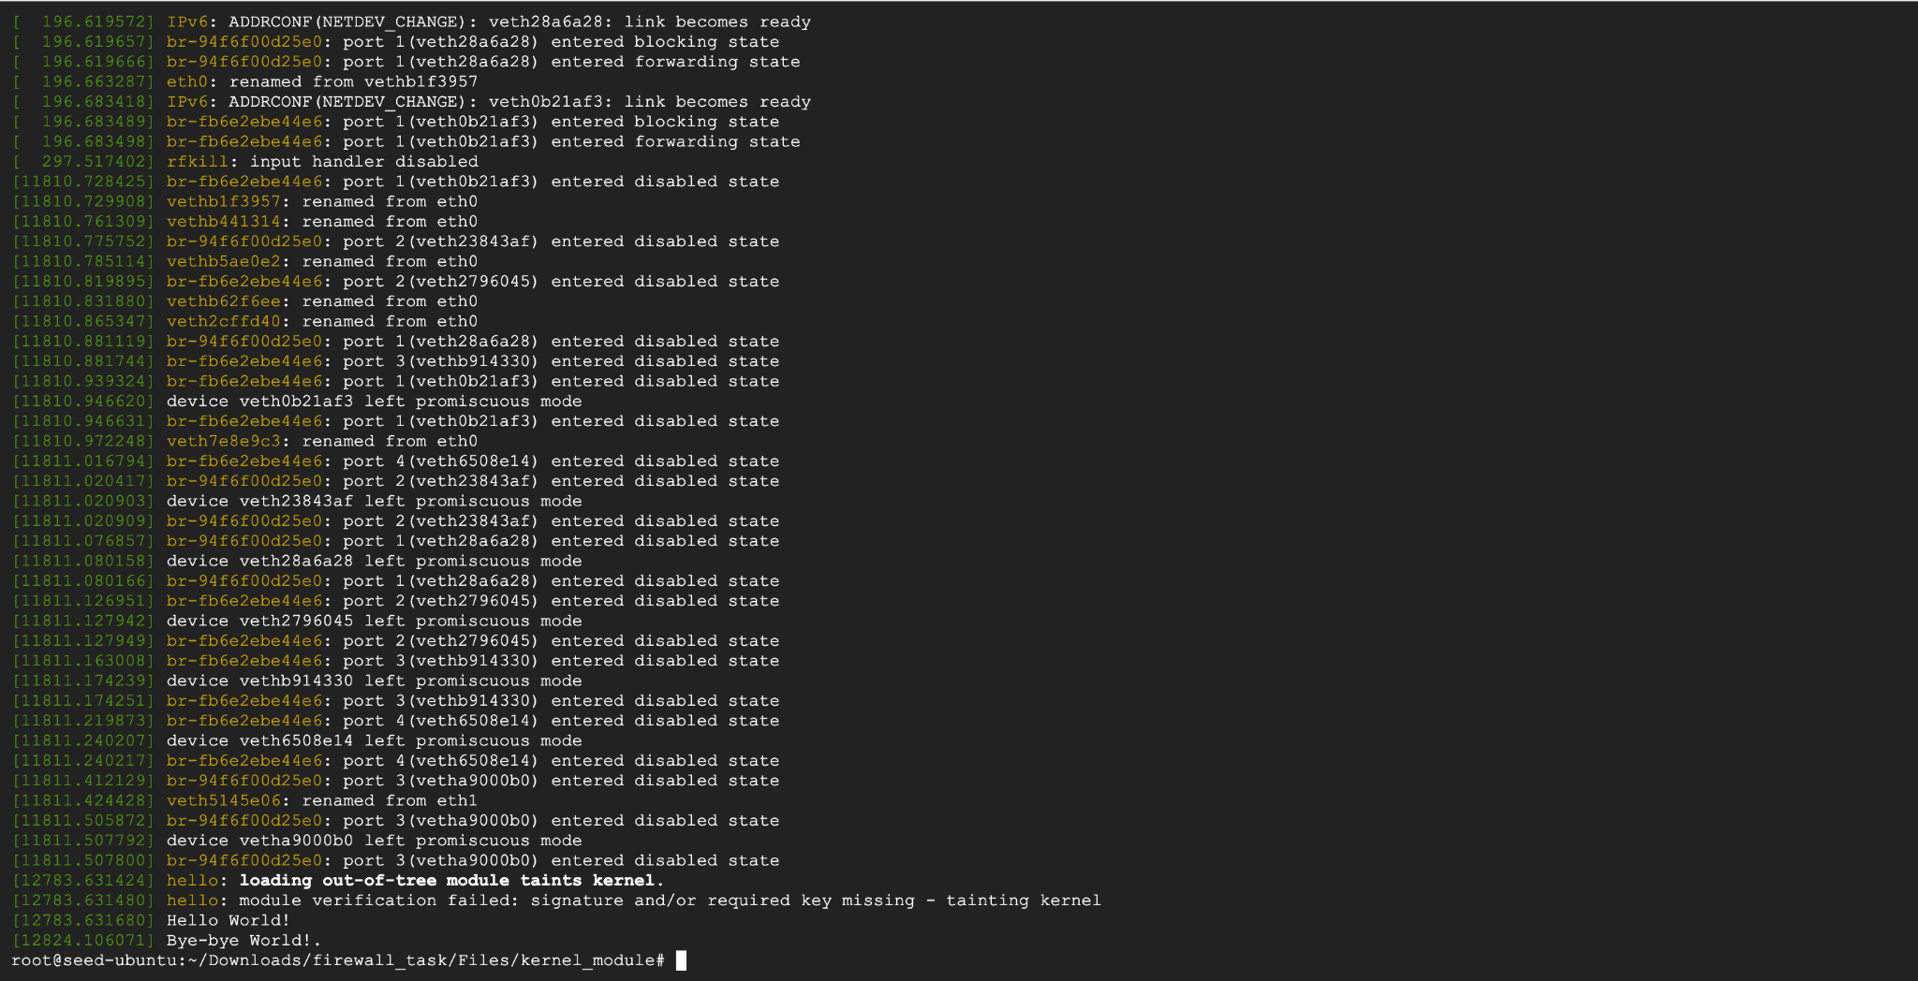

**Task 1.B: Implement a Simple Firewall Using Netfilter**

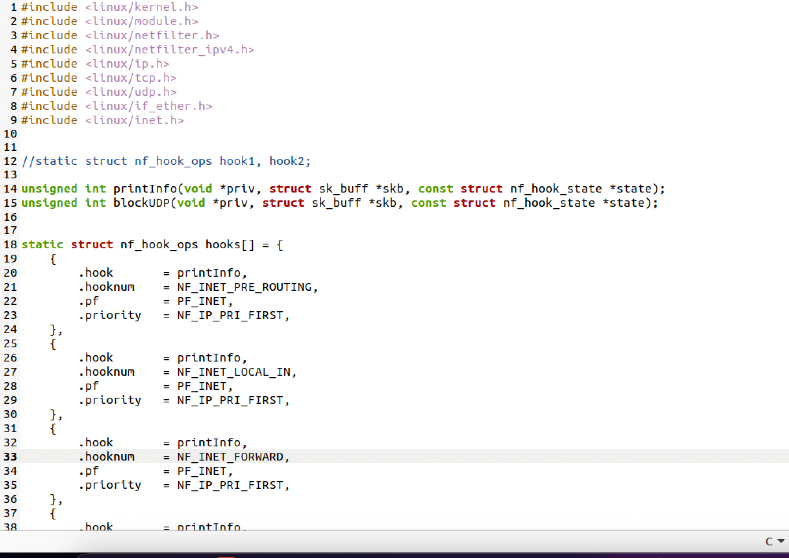

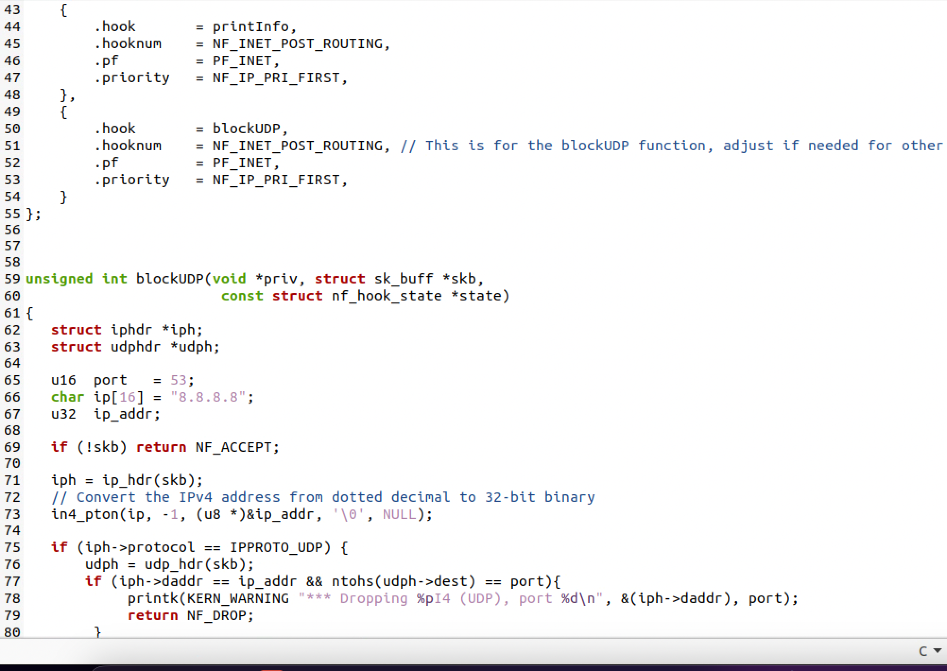

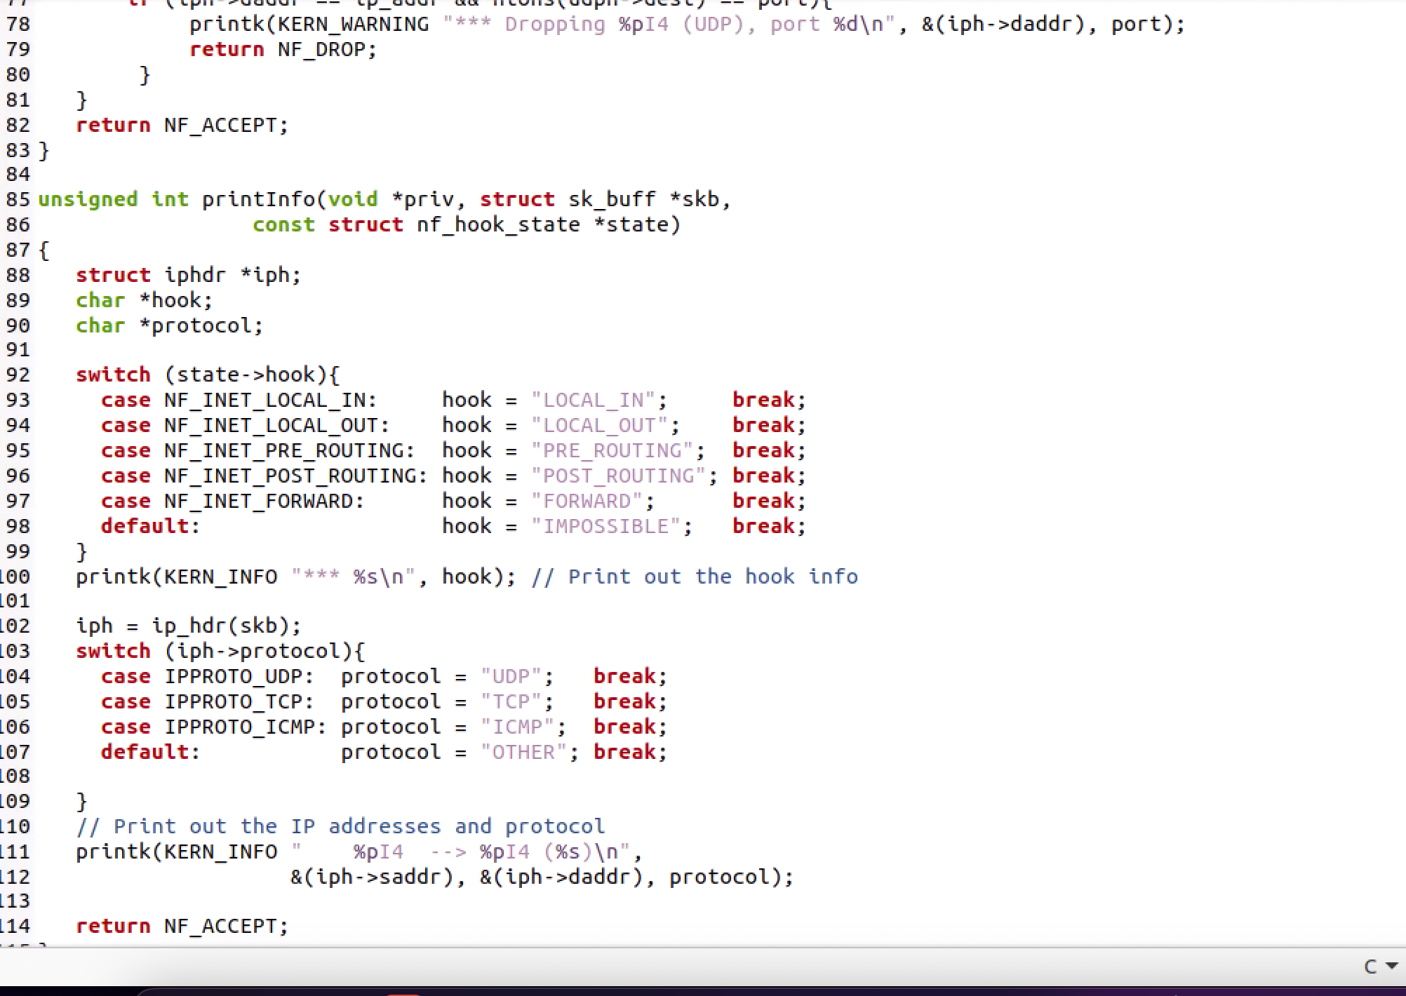

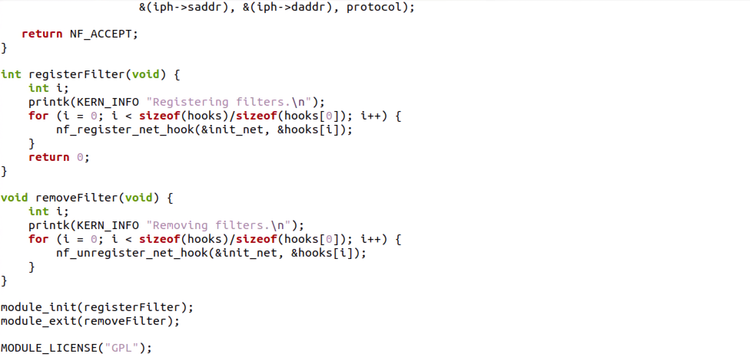

Generating UDP packets to 8.8.8.8, which is Google’s DNS server and request is blocked

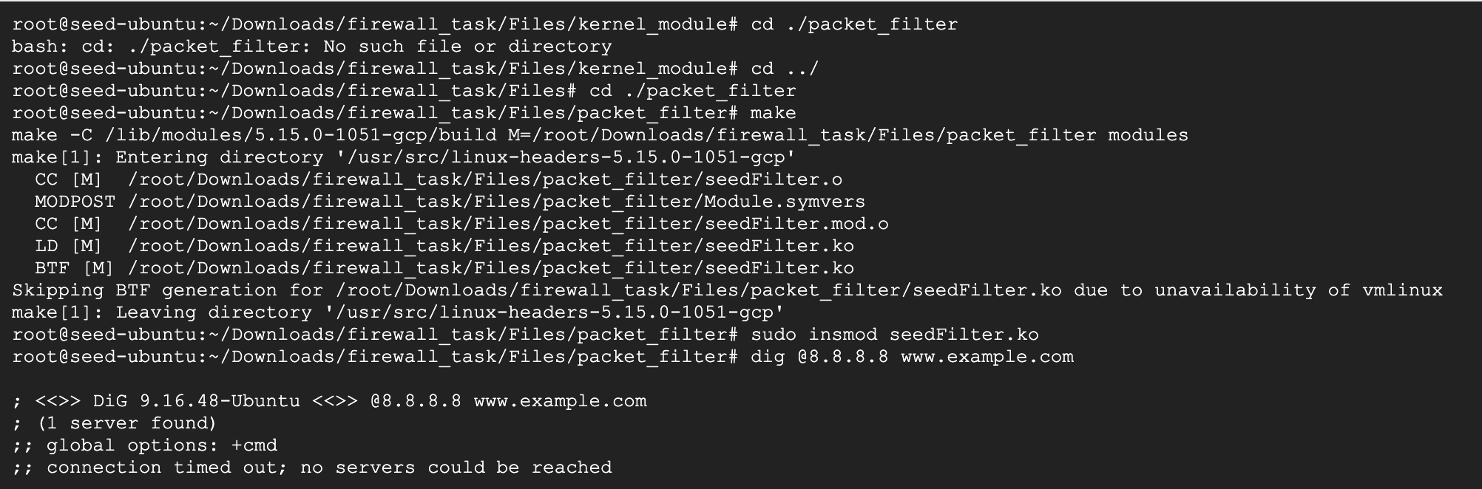

Hooked the printInfo function to all of the netfilter hooks

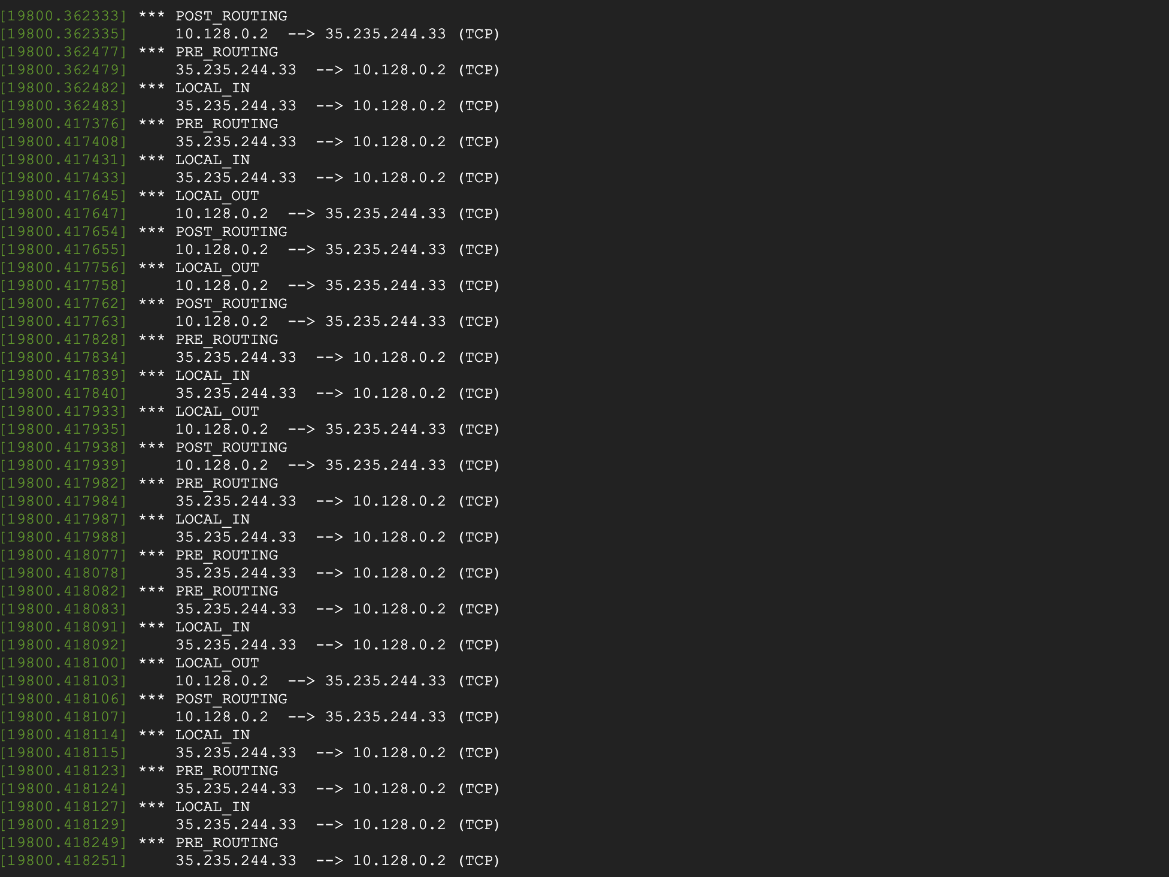

Implemented two more hooks to achieve the following: (1) preventing other computers to ping the VM, and (2) preventing other computers to telnet into the VM:

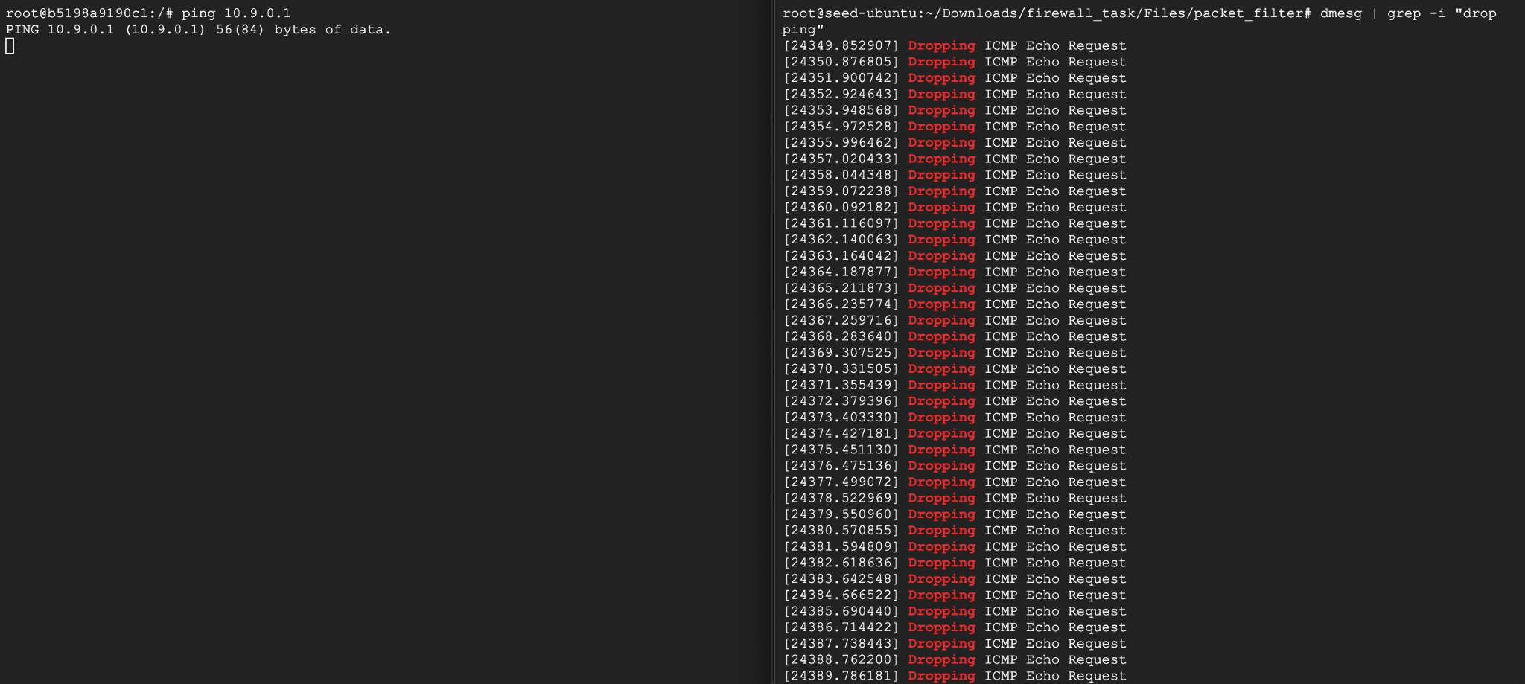

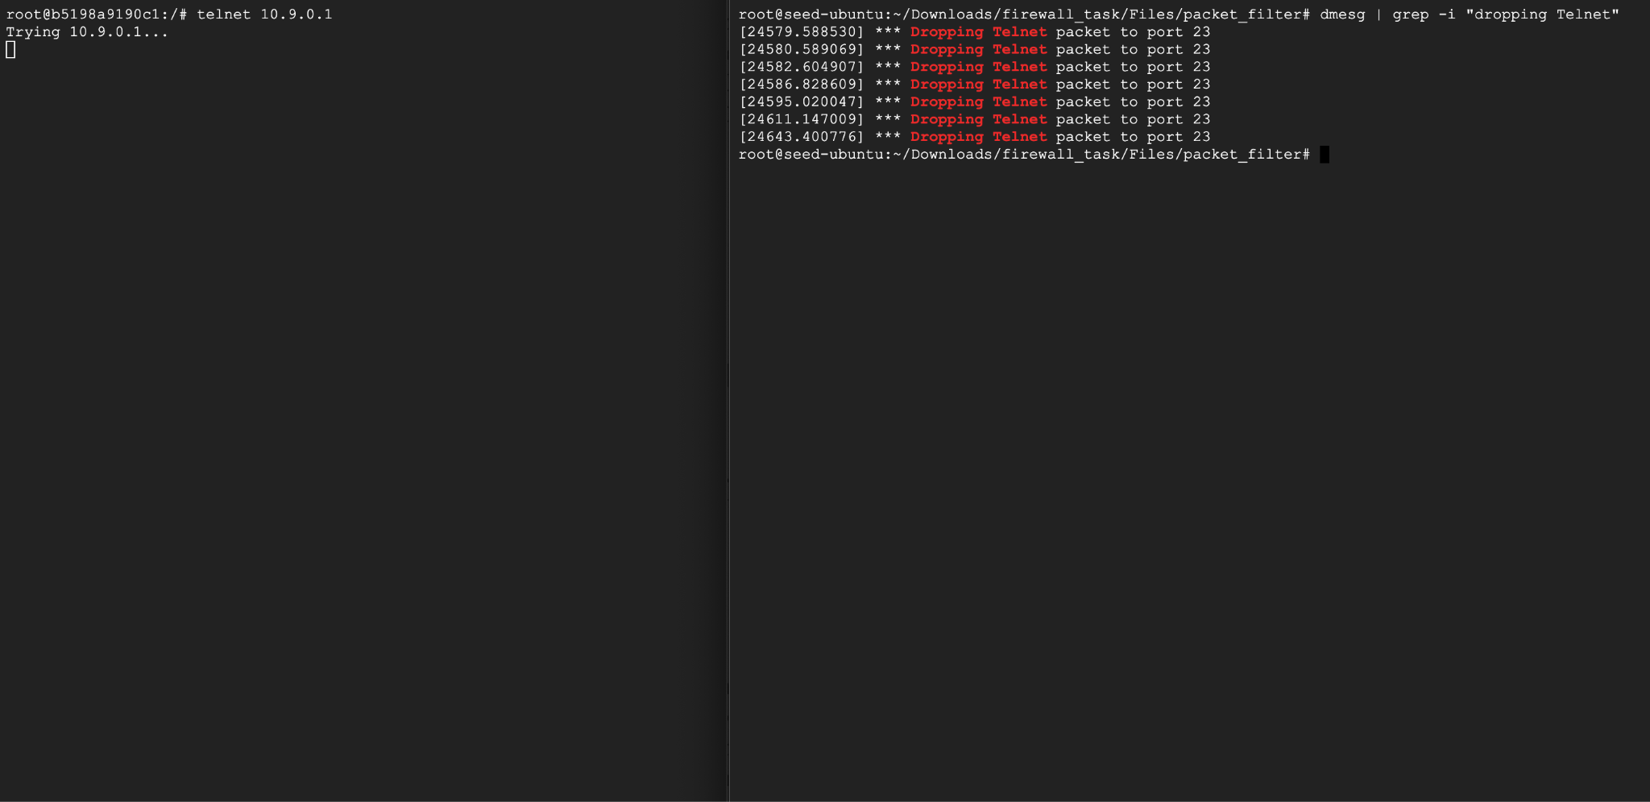

**Task 2: Experimenting with Stateless Firewall Rules**

**Task 2.A: Protecting the Router**

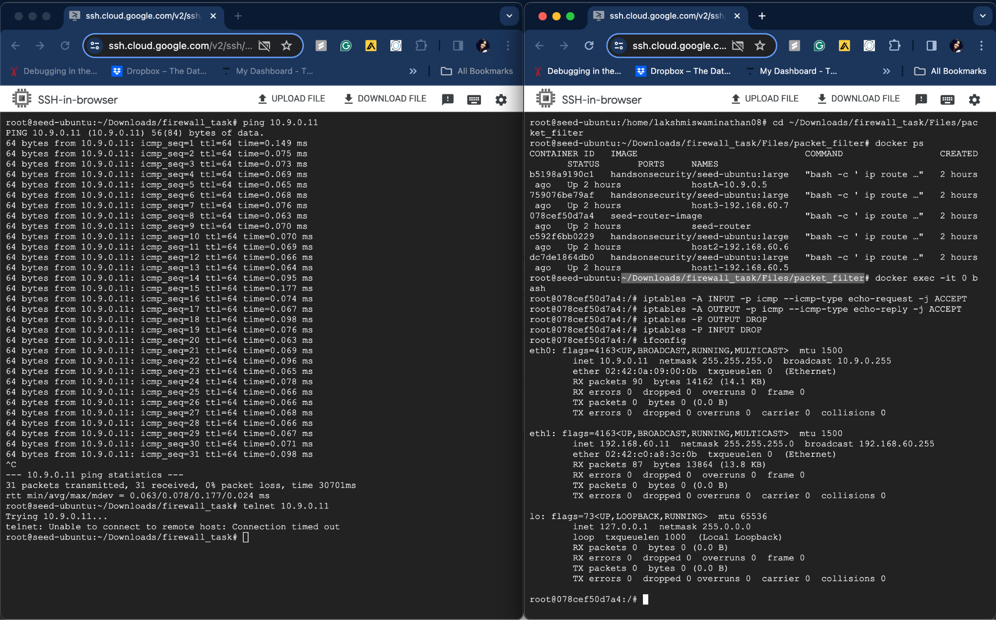

**Task 2.B: Protecting the Internal Network**

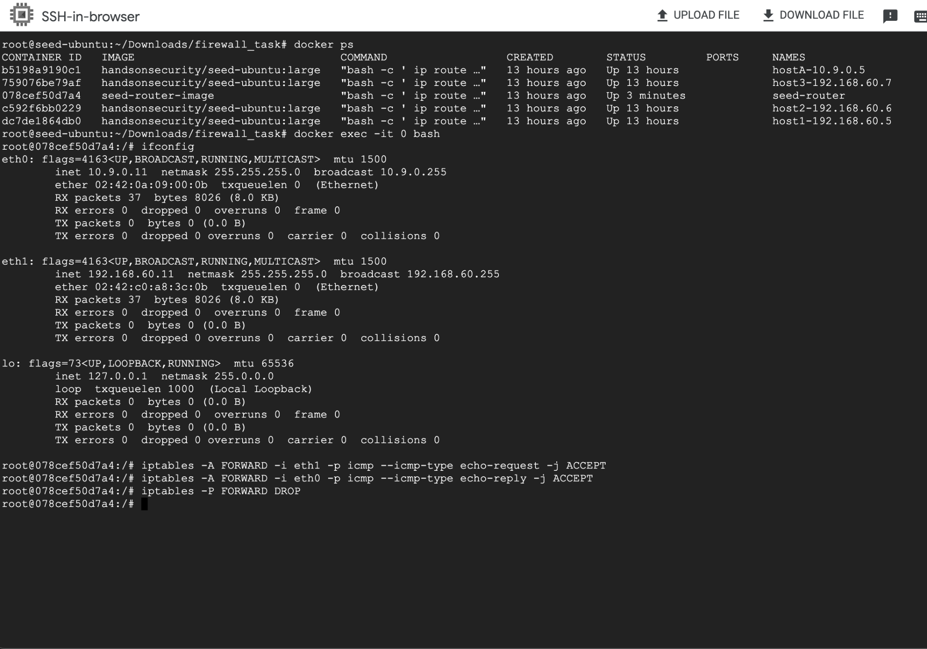

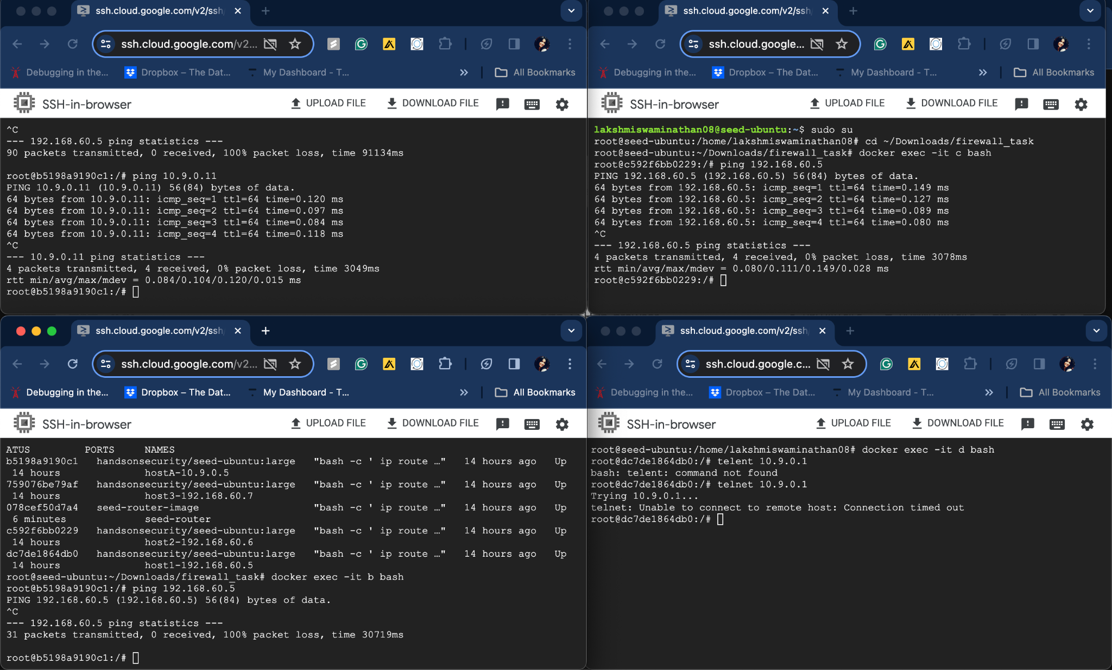

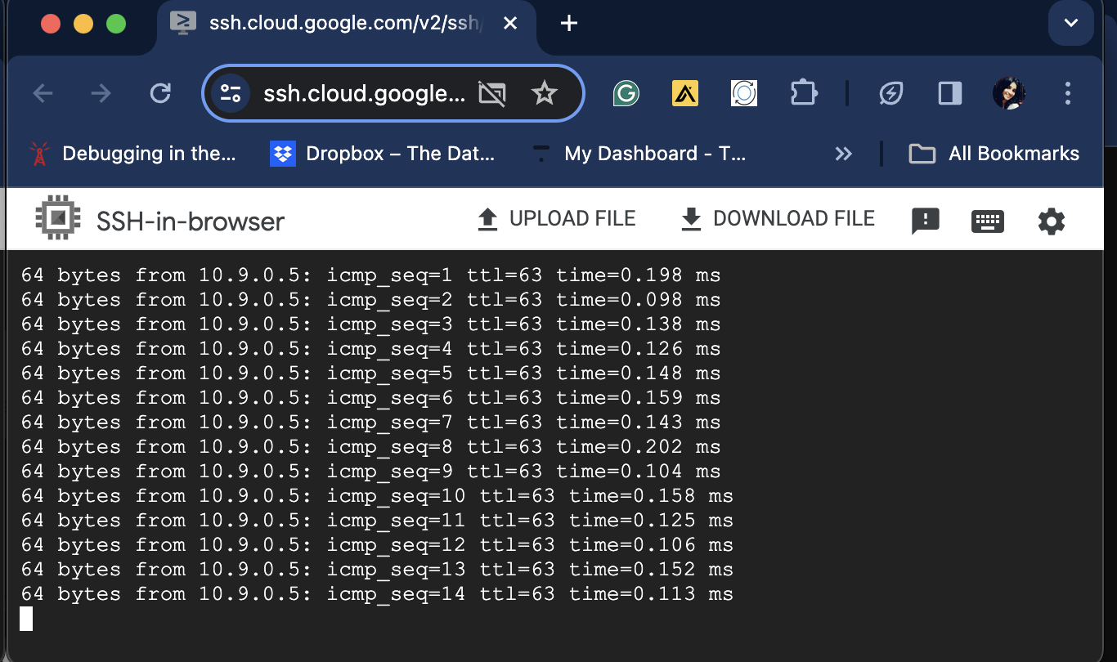

**Task 2.C: Protecting Internal Servers**

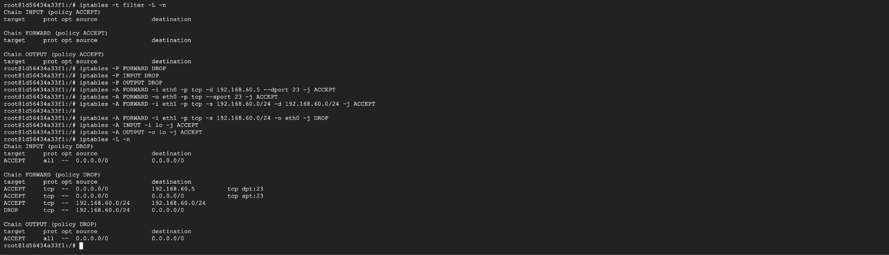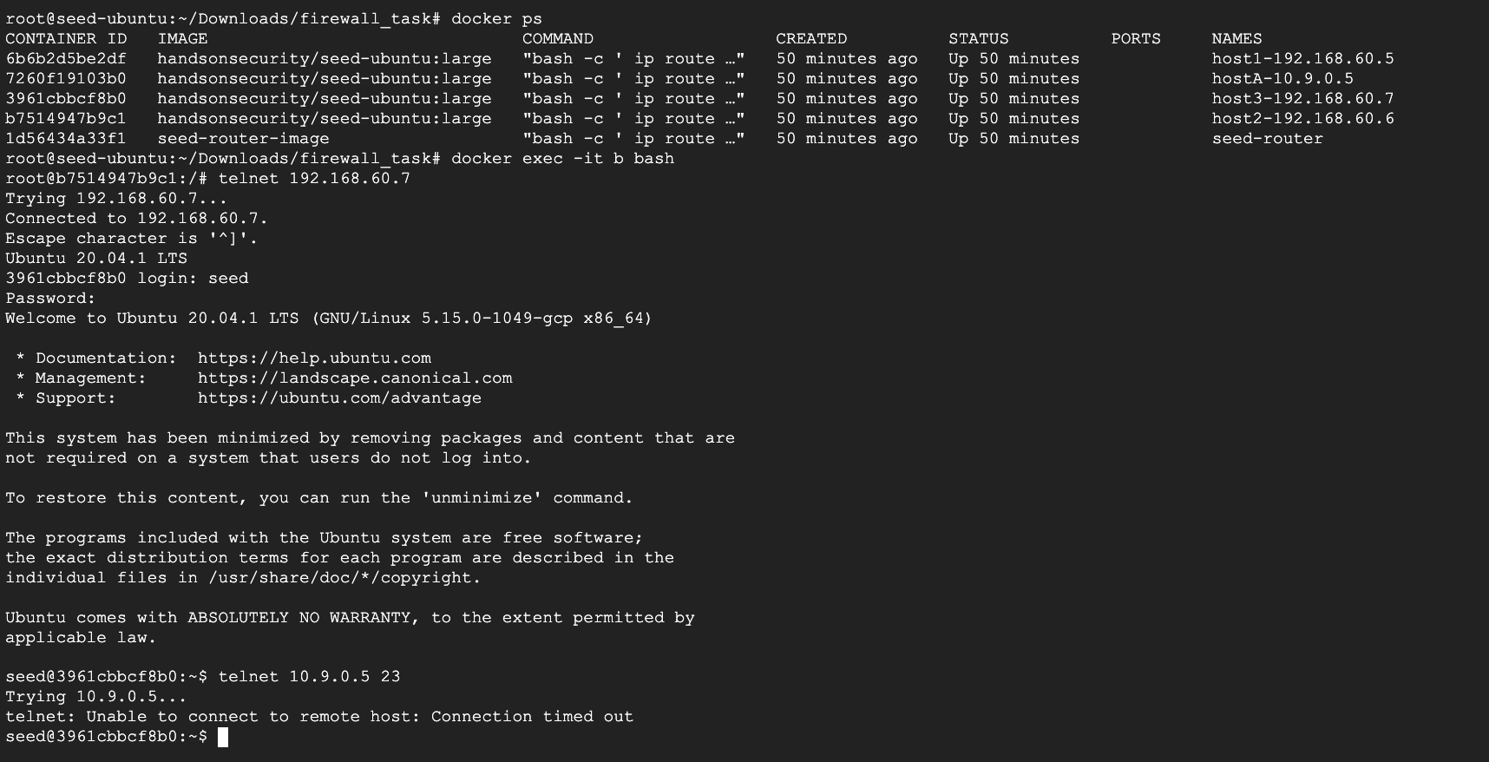

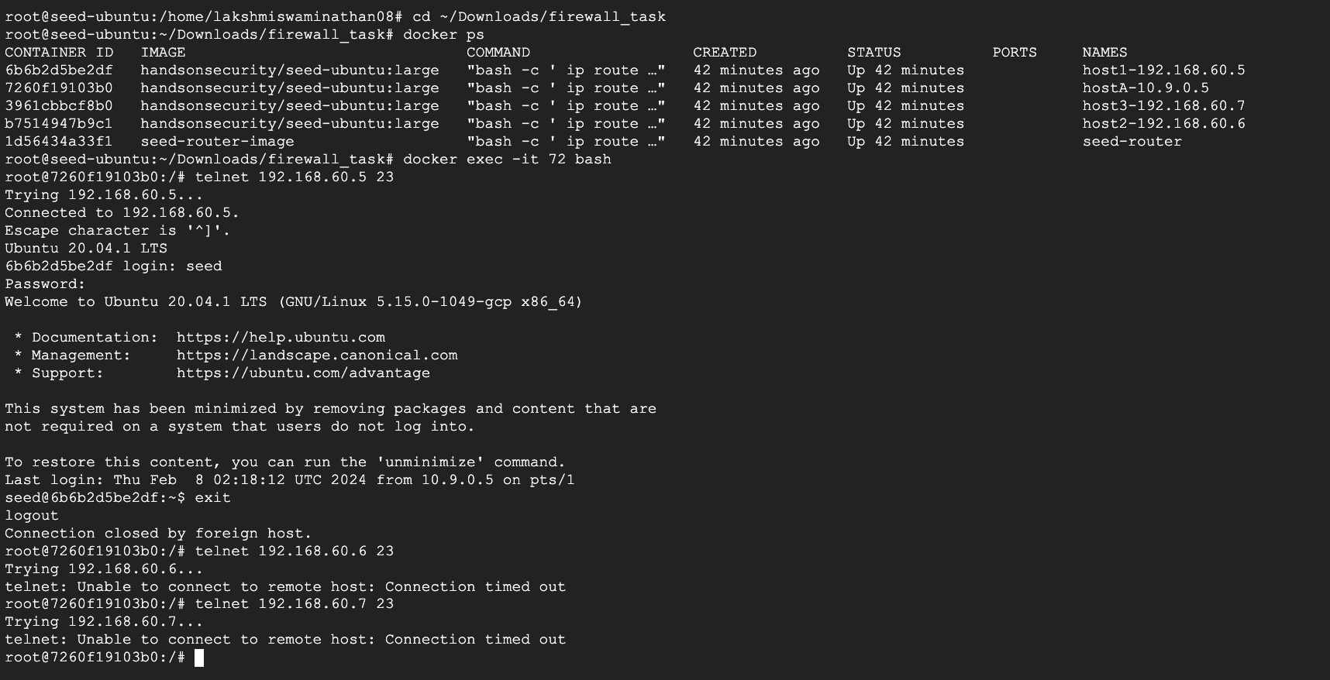

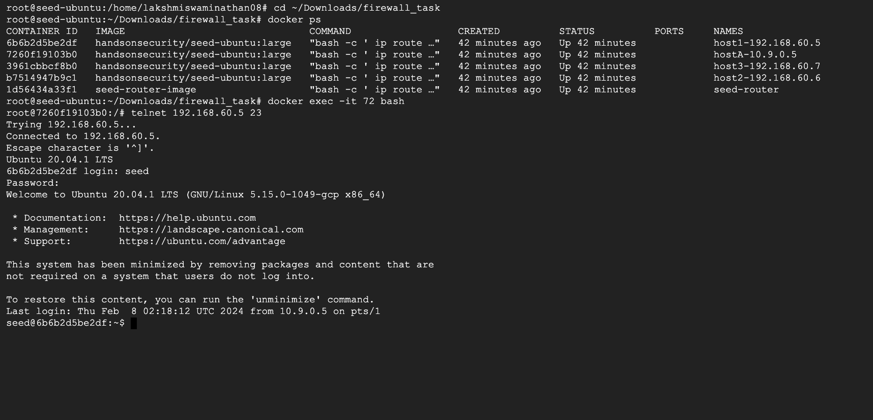

**Task 3: Connection Tracking and Stateful Firewall**

**Task 3.A: Experiment with the Connection Tracking**

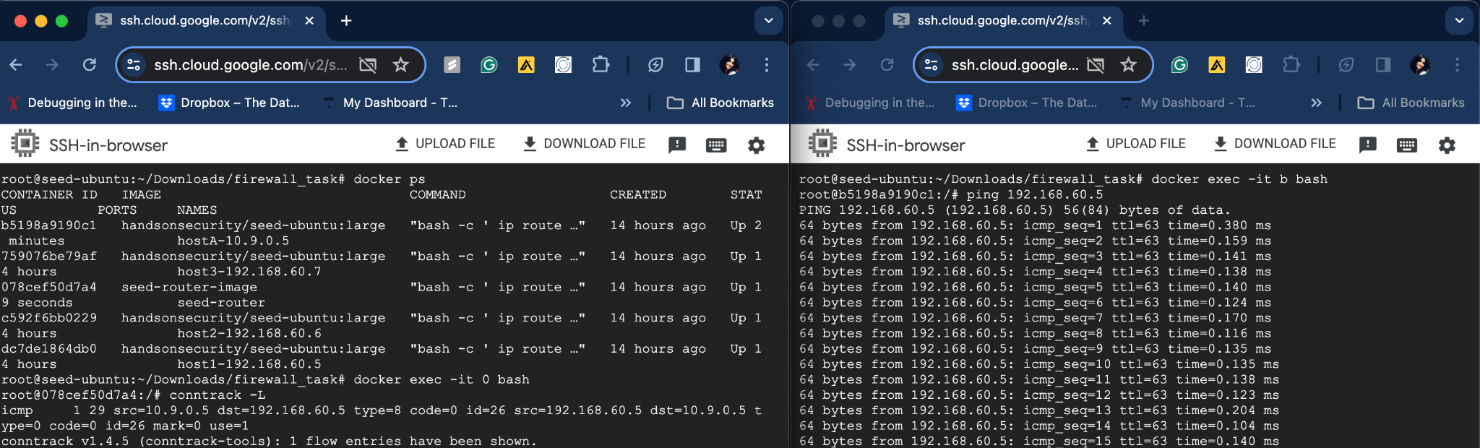

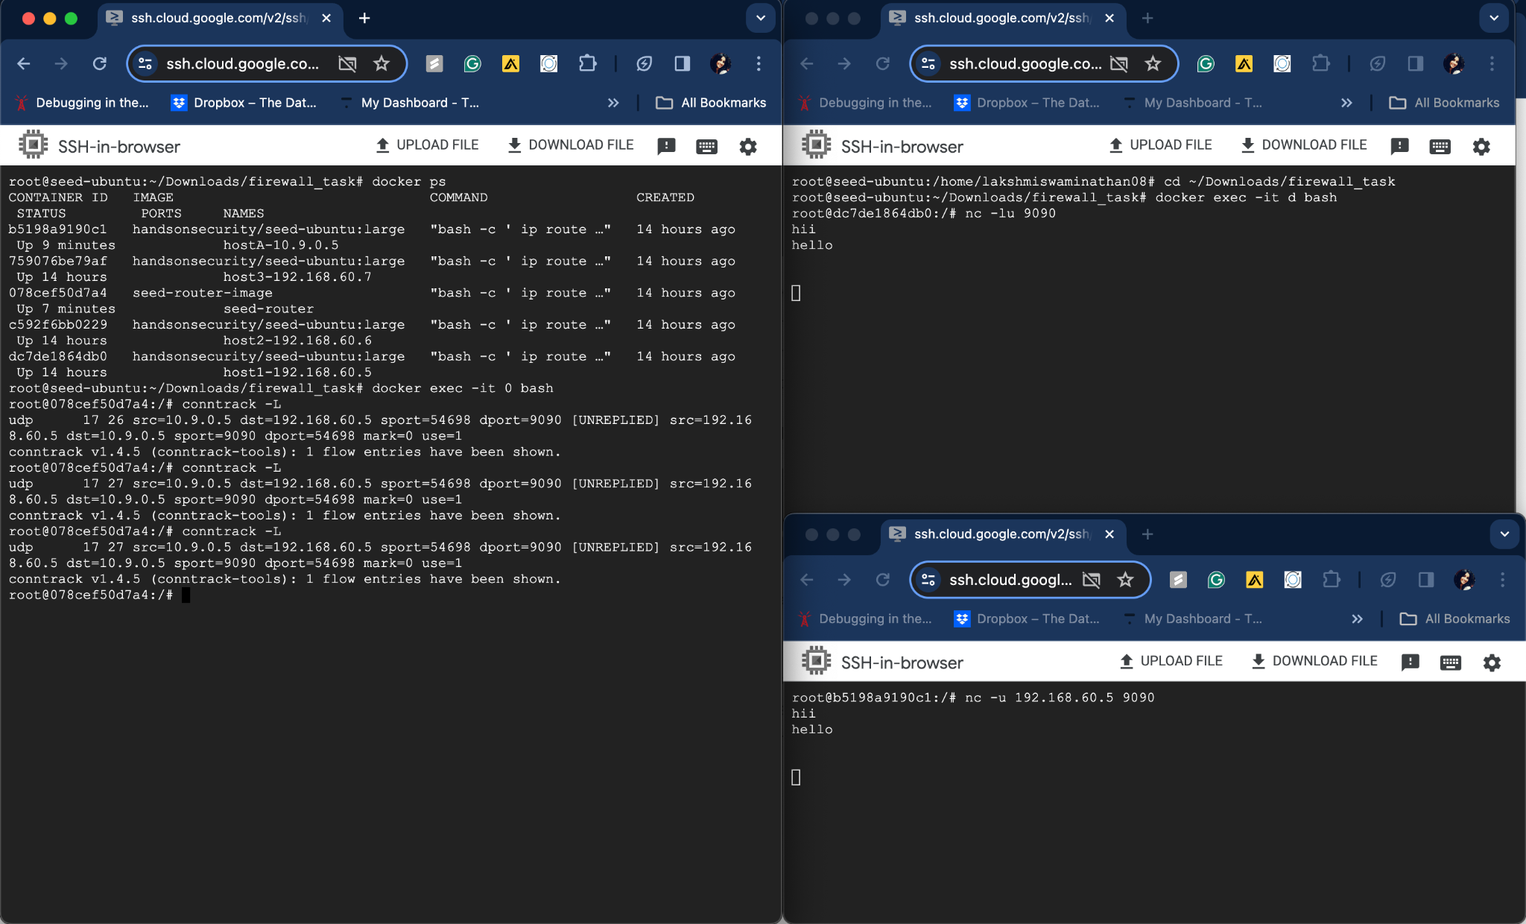

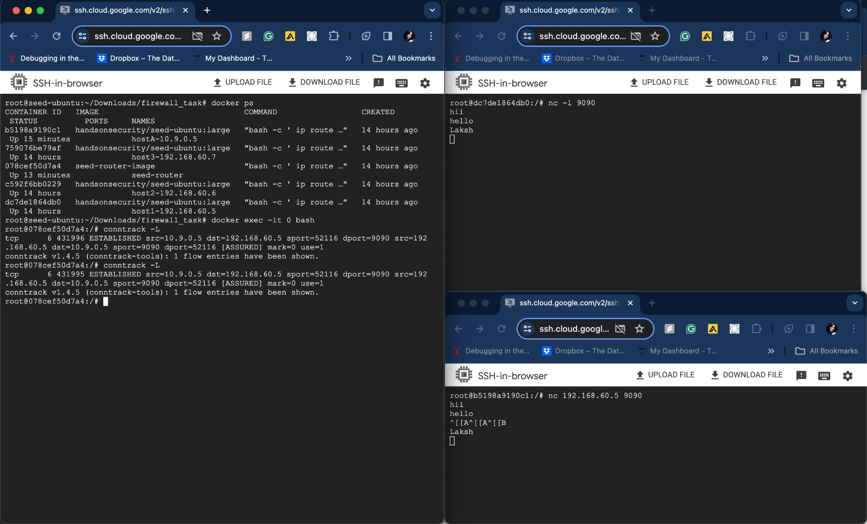

**Task 3.B: Setting Up a Stateful Firewall**

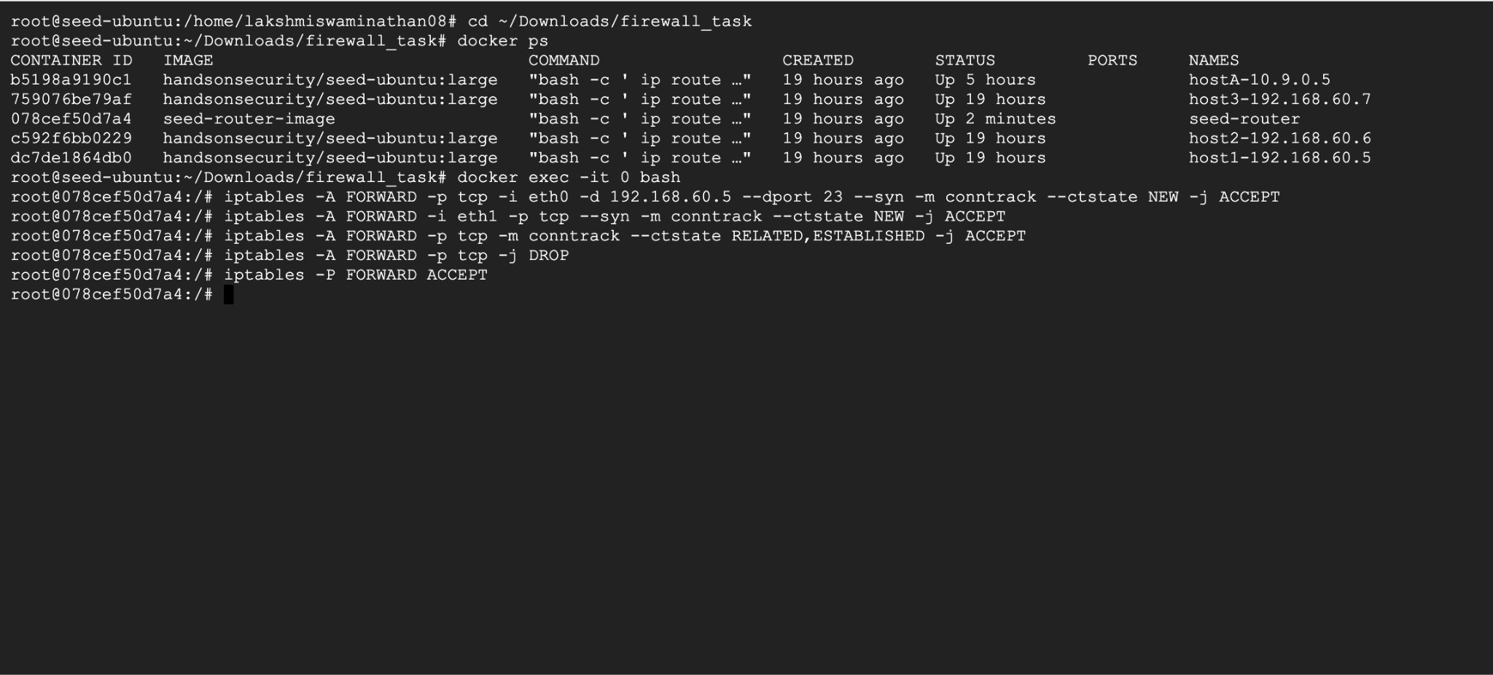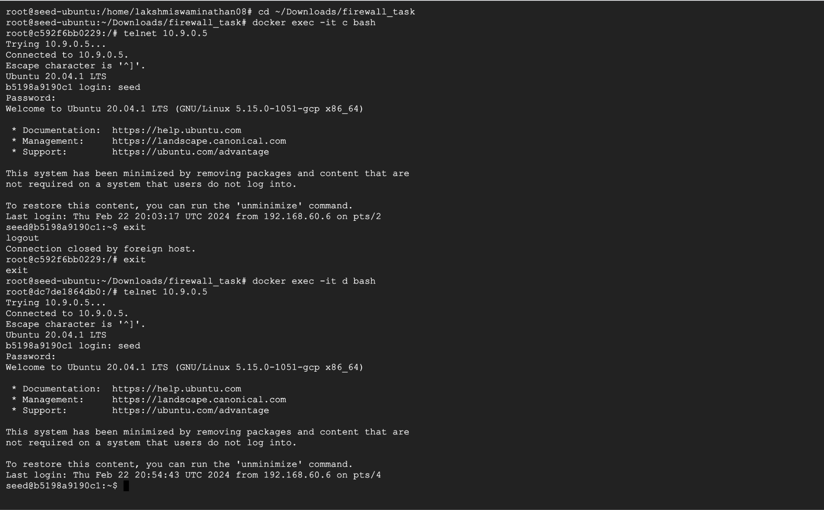

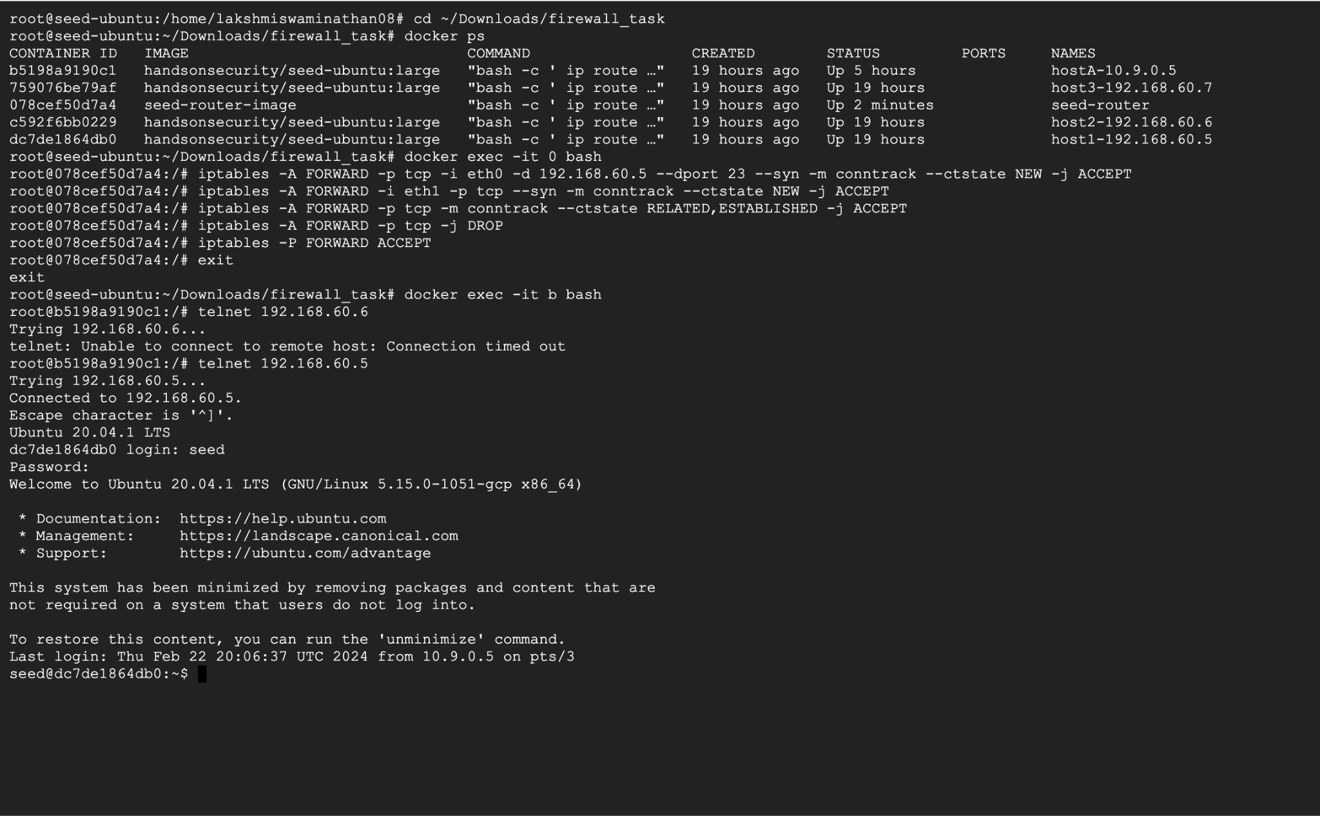

**Task 4: Limiting Network Traffic**

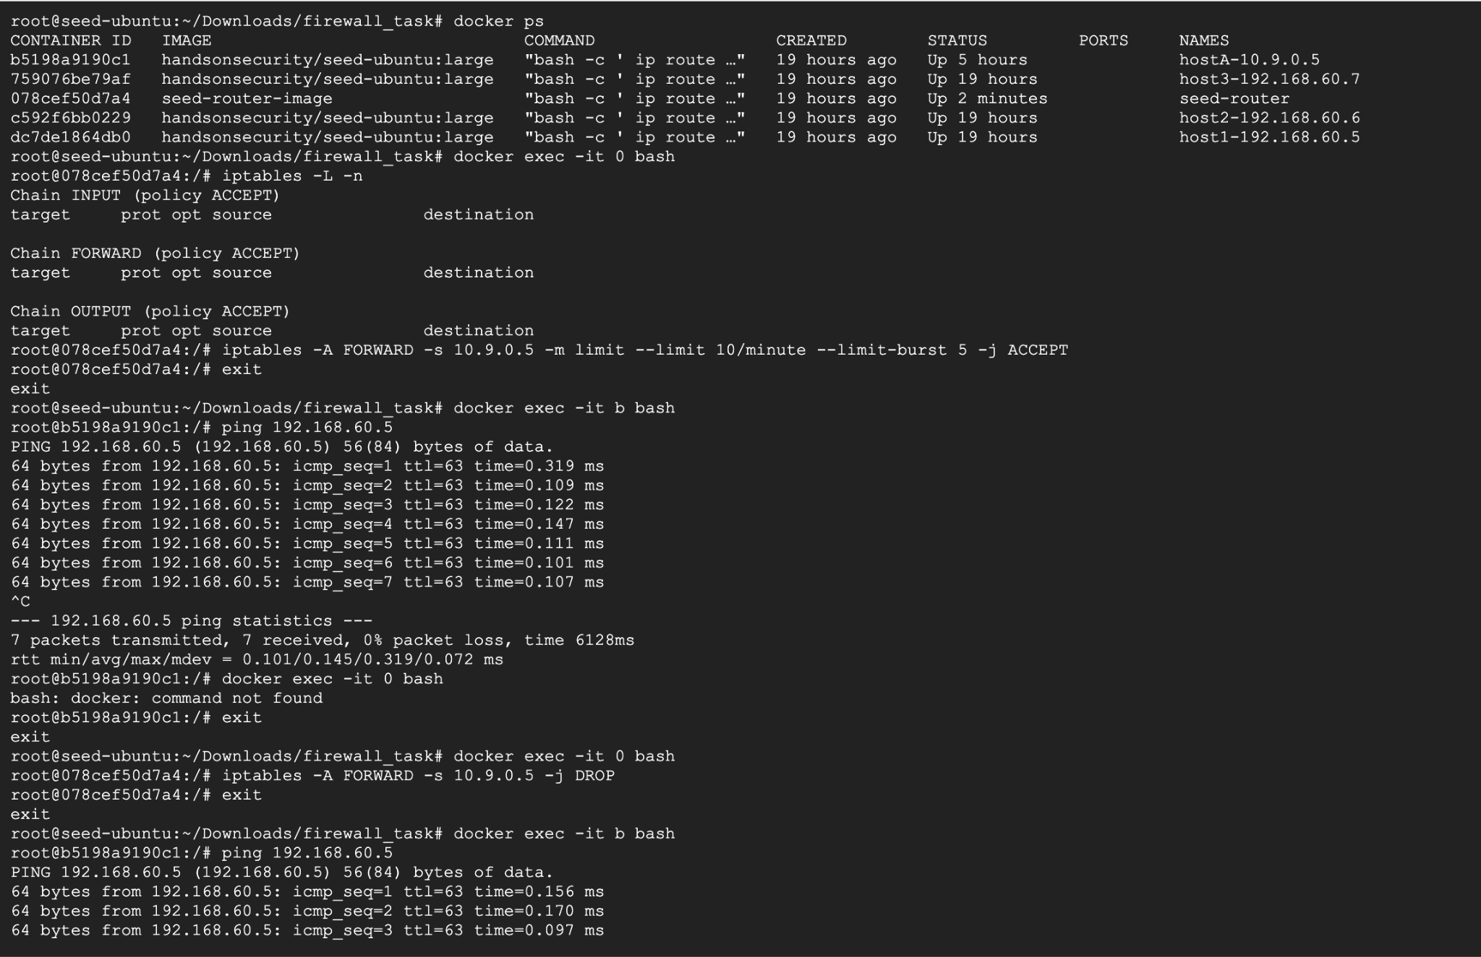

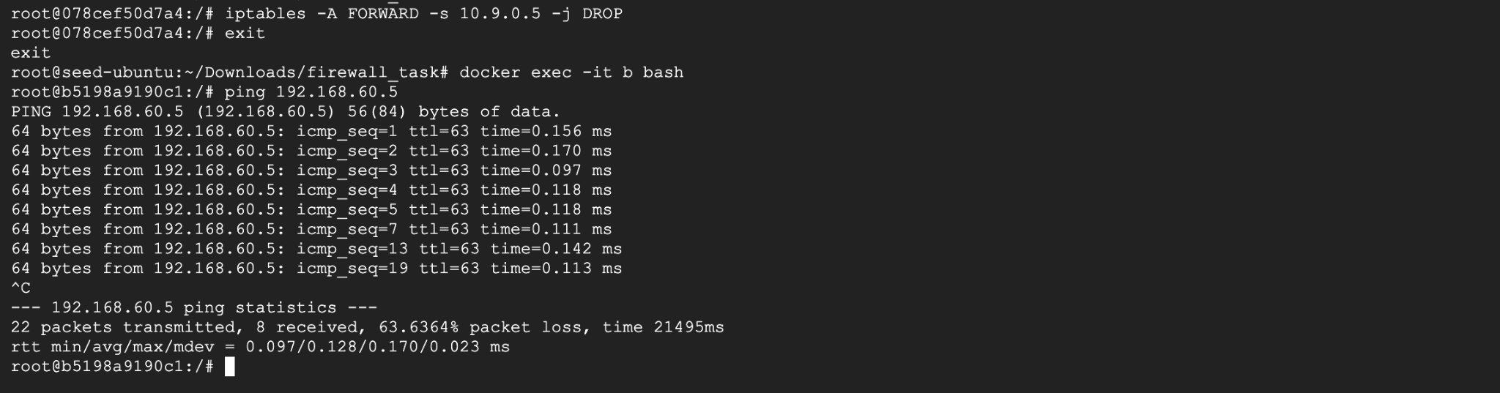

**Task 5: Load Balancing**

**Load Balancing using Round Robin:  
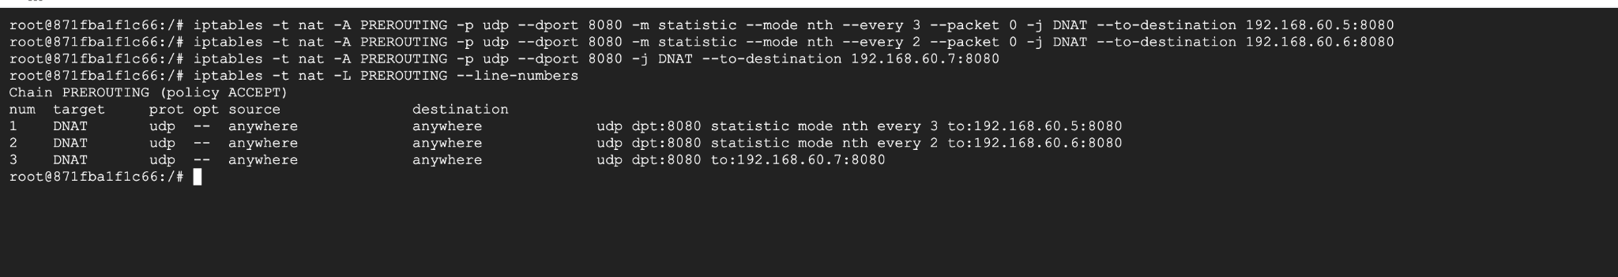**

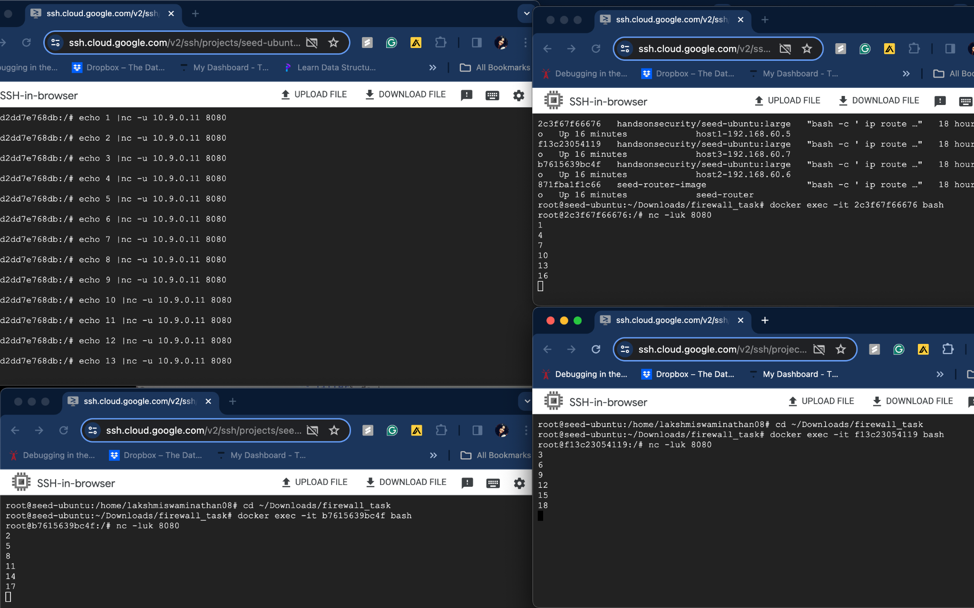

**Using the random mode.**

